**Aged Style Absinthe, Bieres & Vins Decorative Mirror**

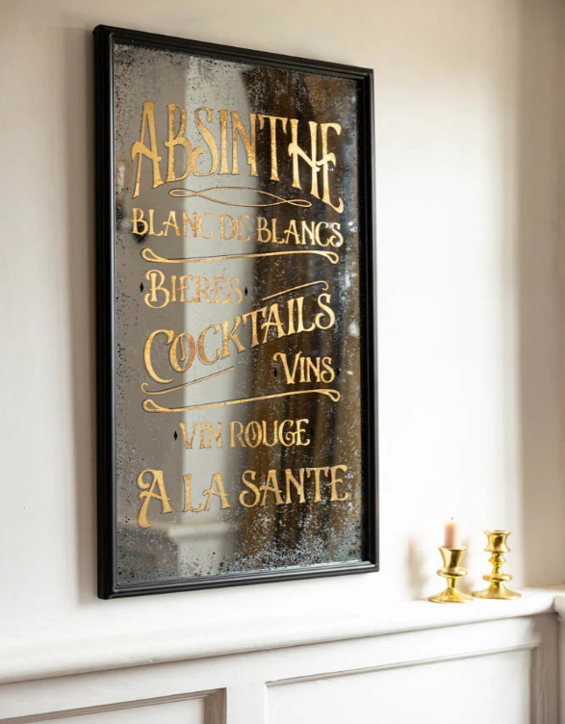The "Aged Style Absinthe, Bieres & Vins Decorative Mirror" is a stunning piece that blends vintage charm with sophisticated artistry. Inspired by the timeless allure of French absinthe, beers, and wines, this mirror adds a touch of class to any space. The frame is designed with intricate detailing, showcasing elements of aged wood and metal, evoking the rustic, nostalgic feel of a traditional European bar or distillery. Its elegant design makes it a perfect statement piece for homes, cafes, or bars, bringing a sense of history and refinement to your decor. Ideal for those who appreciate vintage aesthetics, this mirror serves not only as a functional item but also as a captivating decor element.